INVOICING FINISHED GOODS DELIVERED BY THE VENDOR

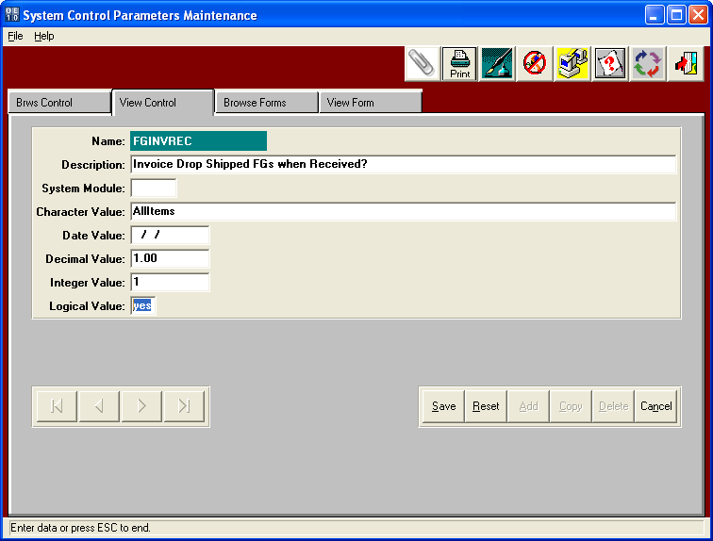

The N-K-1 Parameter called FGINVRES must be set to YES to automate the process.

This option will create an Invoice for finished goods receipts for purchased finished goods that were created as a drop shipment to a customer. This logic would save many steps for purchased finished goods dropped shipped, which simply place purchase orders then invoice the delivery.

LOGICAL VALUE - When the logical value is YES, finished goods posting will automatically create an Invoice for Finished Goods receipts via purchasing with a purchase order type of D for Drop Shipped. First an purchase order is created for a finished goods that is purchased as a drop shipment type purchase order. Therefore, the vendor on the purchase order will deliver the finished goods directly to the to the customer. When the vendor notifies the box maker that the goods have been delivered, the finished goods receipt should be entered. The finished goods receipt will prompt "Create Invoice for Drop Shipped Purchase Order? YES. Will flag the item during FG posting to automatically update the release quantity to the finished good receipt quantity, post the release and post the bill of lading, which will create the invoice. The bill of lading will have the same warehouse / bin location as the finished goods receipt.

CUSTOMER SALES ORDERS

FOR DROP SHIPMENT for PURCHASED FINISHED GOODS

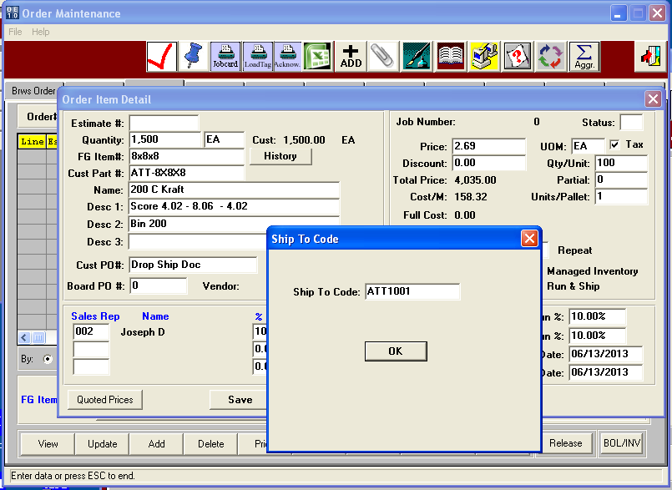

Customer Sales Orders are created just as any other order however, since the item is purchased, there will be no estimate, thus no job created. Customer service simply enters the quantity and finished goods item with pricing and delivery address.

PURCHASE ORDER for DROP SHIPMENT

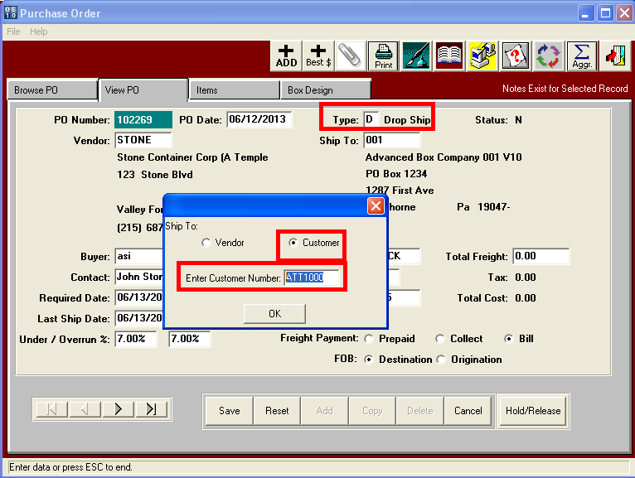

PURCHASE ORDER ITEM TAB for DROP SHIPMENT MUST HAVE CUSTOMER ORDER NUMBER

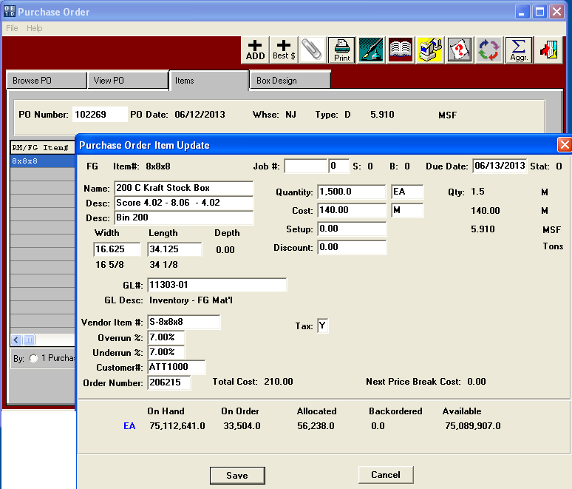

Notice the Customer order Number is entered on the purchase order Items tab. This links the purchase order to the vendor to the sales order for the customer. The purchase order ship to is listed as the customer ship to location as opposed to the normal box plants address.

FINISHED GOODS RECEIPTS for DROP SHIP QUANTITY

Once the Vendor notifies you that the delivery was made, customer service will then click the I-U-1 menu in Advantzware to receive the goods which is used to enter the quantity of items delivered. Customer Service must answer YES to the question to invoice the items that were dropped shipped.

Pallet Load Tags are not created for drop shipments.

In addition, customer service does create a release for the sales order.

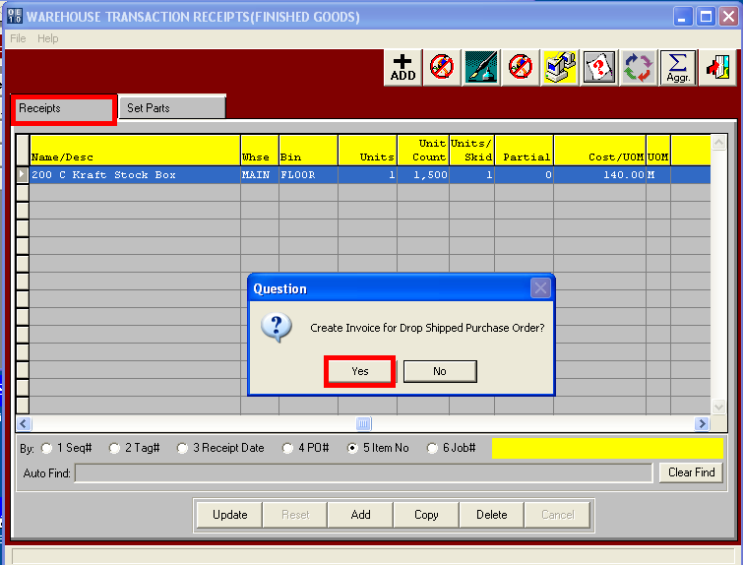

FINISHED GOODS RECEIPTS AUTOMATICALLY CREATES THE INVOICE

When the finished goods are posted, the Advantzware software automatically creates a release, posts the bill of lading and creates the invoice to the customer. This provides transaction records for inquiry and reporting purposes. In addition, the receipt adds to on hand but the bill of lading immediately reduces the on hand quantity. The accountant simply has to print the invoice, check the pricing and post the invoice to the general ledger as normal.

